**Task1: Create a program using jmp statement to tell if first number is greater or lesser**

.model small

.stack 100h

.data

var1 db 5

var2 db 10

greater db "greater$"

lesser db "lesser$"

.code

main proc

mov ax,@data

mov ds,ax

mov bl,var1

cmp bl,var2

jl label2

jg label1

label1:

mov ah,09

lea dx, greater

int 21h

jmp exit

label2:

mov ah,09

lea dx, lesser

int 21h

exit:

mov ah,4ch

int 21h

main endp

end main

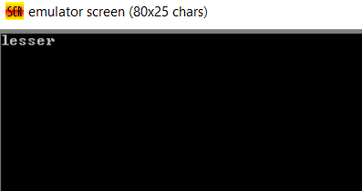

**Task 2: Read a number from a keyboard if number exactly equals 5, than display a message that the number is 5 else display nothing**

.model small

.stack 100h

.data

var1 db 'number is five$'

.code

main proc

mov ax,@data

mov ds,ax;

mov ah,01

int 21h

mov bl,al

cmp bl,'5'

jl exit

jmp exit

isFive:

mov ah,09

lea dx , var1

int 21h

exit:

mov ah,4ch

int 21h

main endp

end main

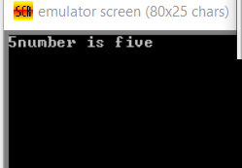

**Taks 3 : Read a number from a keyboard if number exactly equals 5, than display a message that the number is 5 else display that number is not 5**

.model small

.stack 100h

.data

var1 db 'number is five$'

var2 db 'number is not five$'

.code

main proc

mov ax,@data

mov ds,ax;

mov ah,01

int 21h

mov bl,al

cmp bl,'5'

je isFive

jmp notFive

isFive:

mov ah,09

lea dx , var1

int 21h

jmp exit

notFive:

mov ah,09

lea dx, var2

int 21h

jmp exit

exit:

mov ah,4ch

int 21h

main endp

end main

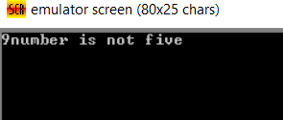

**Task 4: Read a sequence of characters and stop reading the character when enter key is pressed**

.model small

.stack 100h

.data

var1 db 'number is five$'

var2 db 'number is not five$'

.code

main proc

mov ax,@data

mov ds,ax;

takeInput:

mov ah,01

int 21h

cmp al,13

je exit

jmp takeInput

exit:

mov ah,4ch

int 21h

main endp

end main

**Task 5: Write a program to read two number and display maximum number from the two**

.model small

.stack 100h

.data

var1 db ?

var2 db ?

.code

main proc

mov ax,@data

mov ds,ax;

mov ah,01

int 21h

mov bl,al

int 21h

mov var1,bl

mov var2,al

cmp bl,al

jg blGreater

jl alGreater

blGreater:

mov ah,02

mov dl,0dh

int 21h

mov dl,0ah

int 21h

mov ah,02

mov dl , var1

int 21h

jmp exit

alGreater:

mov ah,02

mov dl,0dh

int 21h

mov dl,0ah

int 21h

mov ah,02

mov dl ,var2

int 21h

exit:

mov ah,4ch

int 21h

main endp

end main

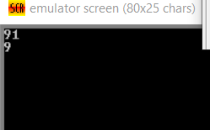

**Task 6: Write a program to read two number and display minimum number from the two**

.model small

.stack 100h

.data

var1 db ?

var2 db ?

.code

main proc

mov ax,@data

mov ds,ax;

mov ah,01

int 21h

mov bl,al

int 21h

mov var1,bl

mov var2,al

cmp bl,al

jg blGreater

jl alGreater

alGreater:

mov ah,02

mov dl,0dh

int 21h

mov dl,0ah

int 21h

mov ah,02

mov dl , var1

int 21h

jmp exit

blGreater:

mov ah,02

mov dl,0dh

int 21h

mov dl,0ah

int 21h

mov ah,02

mov dl ,var2

int 21h

exit:

mov ah,4ch

int 21h

main endp

end main

